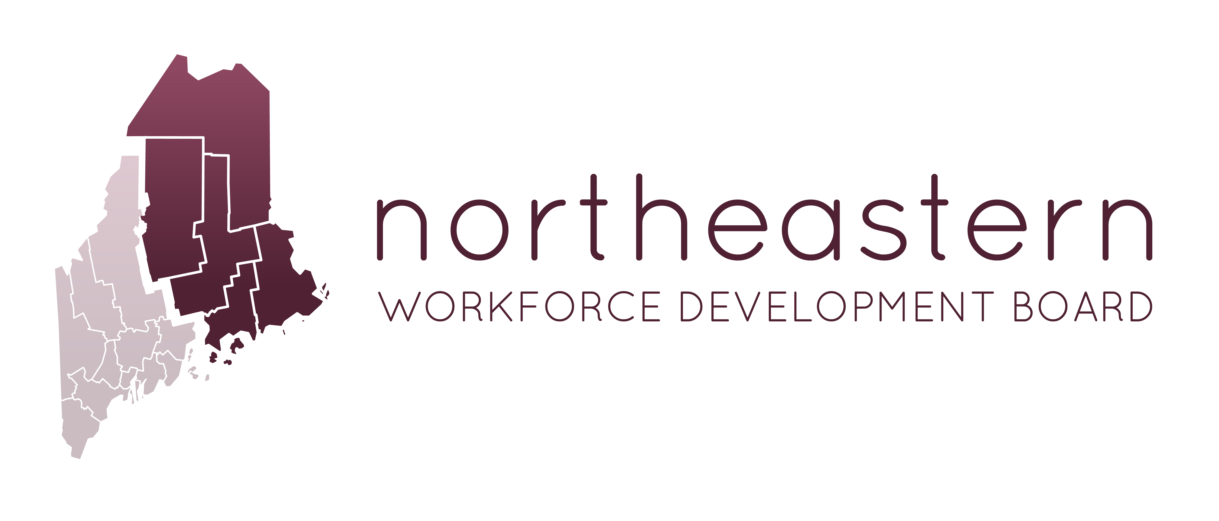

Quarterly NWDB Board Meeting - Zoom
Please Print Clearly
Tuesday, May 15, 2018
4:00pm-5:00pm

Join from PC, Mac, Linux, iOS or Android: https://zoom.us/j/243320662
US: +1 408 638 0968 or +1 646 876 9923 - Meeting ID: 243 320 662

Agenda

- System update – Nikki Fletcher and Joanna Russell
- 2/26/18 Meeting Minute approval - Nikki Fletcher
- Policy Review- Joanna Russell
  - 005 OJT Policy
  - 007 Work Experience and Transition Policy

- NWDB Fiscal and Personnel Policy Manual – Sara McLaughlin and Joanna
- Budget Review – Sara McLaughlin
- Program updates – Service Providers

