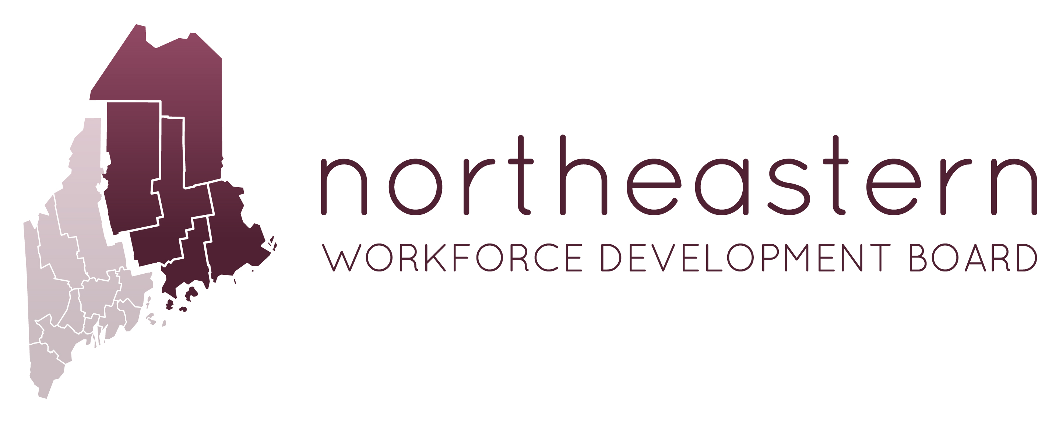

Tri-County One Stop Partners - Youth Services
May 14, 2018 1:00pm-2:30pm
Tri County CareerCenter
45 Oak Street, Bangor – Piscataquis conference rooms
https://zoom.us/j/668512751
US: +16468769923,668512751# or +16699006833,668512751#
Meeting ID: 668 512 751

Agenda
- Introductions – Joanna Russell
- Review of NWDB Activities – Joanna Russell
- Update on EMDC’s Youth Employability Services
- EMDC’s WIOA Youth Program Status – Jon Farley
- EMDC’s “Northern Maine AmeriCorps Collaborative” Project Description and Status - Hook Wheeler and Vessa Villareal
- EMDC’s Tech Hire Project Description and Status – Ryan Grindle

- Discussion of other Youth Employability Services in the Region and Opportunities for Collaboration – Jon Farley

