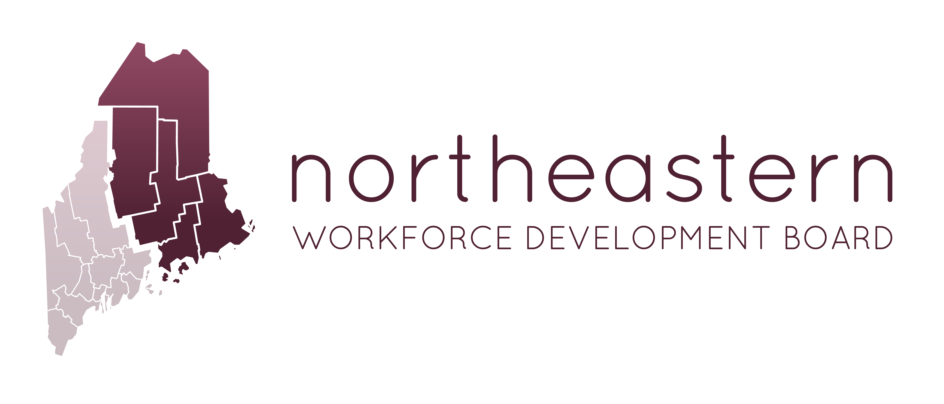

In-Person Board Meeting
Penobscot Commissioners’ Chambers
97 Hammond Street, Bangor, ME 04401
Monday, February 26, 2018
3:00pm-5:00pm

Meeting Minutes
Present  Board Members  Denice Conary, Penquis Cap  Nikki Fletcher, Bangor Savings Bank  Jon Farley, Eastern Maine Development Corporation  Christy Daggett, ACAP  Julie Johnston, Wayfair  Scott Kennedy, N.S. Giles Foundation, Inc.  Nichole Jamison, MDOL WIOA Formula Programs  NWDB Staff  Joanna Russell, NWDB – Executive Director  LaNiece Sirois, NWDB, Workforce Coordinator  Sara McLaughlin, Financial Manager  County Commissioners  Commissioner Paul Underwood, Aroostook County  Commissioner Vinton Cassidy, Washington County  Guests  Judy Alexander, County of Penobscot  Mark Kontio, Congressman Poliquins Office  Jen Peters, SCEC  Carol Woodcock, Senator Collins office  Garrett Oswald, State Workforce Board  David Klein, BES | Present via ZOOM  Board Members  Danny MacDonald, Eastern Aroostook Adult and Community Ed  Terri Swanson, Witham Family Hotels  Andrea Bickford, MDOL- (BRS-DBVI) & Vocational Rehab  Lee Umphrey, Harrington Family Health Center  Traci Place, Teamsters#340  Scott Moulton, Rowell's Garage, Inc  Patty Perry, MDOL-BES  Robin Doody, EMHS  Commissioner Jim White, Piscataquis County  Leah Buck, Maine Community College System  Guests  Edie Smith, Senator Angus Kings office  Absent with notice  Emily Tilton, Central ME Auction Center  John Herweh, MMG  Heather Pelletier, Fish River Rural Health  Scott Cuddy, IBEW –Eastern Maine Labor Council  Destiny Demo, Cianbro  Ryan Bushey, Louisiana Pacific Corp

Welcome, Introductions, Housekeeping-travel vouchers – Nikki Fletcher
Nikki Fletcher called the meeting to order at 3:00. Welcome and introductions we made. Travel Vouchers will be sent out via email
Update- WIOA – PY17 Award – SWB Meeting - PY17/PY18- Joanna Russell
The PY 17 WIOA contracts were approved and disseminated to the Service Providers. Joanna reminded the Board that the 2017 contracts did not fall until the new 70/30 big T training rules. These new rules will go into effect in PY 2018. When the State Workforce Board met, Governor LePage walked in for the last agenda item and shared his disappointment with the Local Workforce System. He then proceeded to read a prepared document asking the State Workforce Board to pass a policy that requires the Local Boards to achieve a 70% training requirement in PY18. If they do not obtain that goal, the following year would subsequently place the Board with State offered technical assistance and a decrease of 10% of their funding. If the goals are again unachieved in the next year, the State would decertify the board. The State Board voted 18/3 in favor of the Governor’s proposed policy.

Due to the withholding of WIOA funding from the boards, EMDC issued lay off notices and withdrew their footprint in the Bangor CareerCenter. They are currently housing what is left of their staff in their Harlow Street office building, which is not conducive for effective administration of services. They have minimum staffing in Ellsworth and Dover Foxcroft. They closed their East Millinocket presence. Now that funding is available, they want to reopen East Millinocket. EMDC will re-staff the Bangor CareerCenter; not at their previous level of 8 to 10 staff, but perhaps 2 or 3. The cost per square foot in at about $17, cost savings can be found in IT and phone systems changes. They will also closely consider staffing at the Community College and continue partnerships with Housing Authorities et al. Jon will prepare a plan with BES for the Executive Committee.

Joanna read aloud, a section of President Trumps federal budget proposal that states in part that “each State Governor may designate all local workforce development areas within the state in accordance with the considerations specified in WIOA…reduce the number of local administrating structures....this proviso would allow the Governor to re-designate and consolidate local areas in accordance with the considerations provided in WIOA that apply to locals areas not grandfathered from WIA.” What this means is the Governor could then make Maine a single board State.
The Senators’ representatives for Collins and King assured the Board that this first presidential proposal never passes as presented. Changes will be made in the next 6 to 8 months and they will keep the board apprised if this remains within the budget.

NWDB Budget - Sara McLaughlin
Sara explained that in years past, we had discretionary funds to supplement the WIOA
formula funding, which aided in extending budget line items each year. These
discretionary funds are now very limited. With the use of zoom capabilities, travel can
be lessened to some degree and some staffing can be curtailed as needed.
Julie Johnston motioned to accept the budget report as presented. Denise Conary seconded the motion. Motion unanimously passed.

Presentation of Service Providers – Launching of services
ACAP – Christy Daggett shared a slide presentation sharing staffing changes and grant opportunities.
BES – David Klein will speak in a moment about the upcoming transition
EMDC – Jon Farley shared a slide presentation with his budget plan and goals for the year.

BES withdrawal from PY17 contract- transition plan - David Klein, BES
David Klein shared the State’s exit plans for BES as they discontinue offering WIOA services to their area effective June 30, 2017. They envision a warm hand-off of current participants. They are carefully ensuring that case notes and participant budgets are accurate and easily understood by another provider taking over. They will continue to offer Wagner Peyser and remain working alongside partners and in cooperation with the Service Provider. Currently there are 62 adults, 50 youth and 7 dislocated workers that are open.

Procurement for Washington County – (NWDB Review Committee)
Joanna received a letter from Ed Upham stating that the Bureau of Employment Services would no longer serve as the Service Provider in Washington County. Their services will discontinue on June 30, 2018. Per legal guidance, Joanna would like to invite EMDC and ACAP, our current service providers to submit a proposal to serve Washington County in the interim until the Board can properly procure services. She will ask the Department of Labor if she can do this for 2 years. Partnerships need to reestablish and One Stop Partner’s reengaged and Services Providers are establishing new procedures. These changes take time. Now is not the time to introduce a new provider. In the meantime, the Board can prepare and procure for services for PY 20. The County Commissioners and Executive Board approved this plan, previously. Julie Johnston motioned to approve extending an invitation for EMDC and ACAP to submit bid proposals to serve Washington County as the interim Service Provider for PY 18-PY19. Scott Kennedy seconded the motion. Motion unanimously passed. Abstentions: Nichole Jamison, Patricia Perry, Christy Daggett and Jon Farley.

Consultation for Central Western WDB- Nikki Fletcher and Joanna Russell
Jeff Snedden, Executive Director of the Central Western Workforce Development Board has moved on in his career and the board has appointed an interim successor. They have asked Joanna to serve as a consultant to the director for up to 10 hours per week, outside her normal working hours for the next few months. This request has been approved by the County Commissioners and Executive board. Julie Johnston motioned to approve that Joanna provide consultation services to CWWDB for the next few months for up to 10 hours per week. Jon Farley seconded the motion. Motion unanimously passed.

Update on State Strategic Plan & Steering Committee
The Maine Department of Labor and the State Workforce Development Board will be posting the 2018 modifications to the workforce development state plan for public comment. Partners are strongly encouraged to review the plan and comment as you see fit. Every State and board must submit a strategic plan to receive WIOA funding. Our board must submit a 2-year modification to the State.
The State Steering committee gathered recently to have a conversation equating to: Where are we? Where are we going? And, how do we get there? The Service Providers could not attend this last meeting due to the lack of a contract. With contracts now in place, they will be attending these meetings.
Staff will bring the One Stop Partners back together and recreate our unity and get back on track now that funding in now available to do so.

Next steps and wrap-up – Nikki Fletcher and Joanna Russell
Our next zoom board meeting will be April 25 from 3-4:30. Motion by Julie Johnston and seconded by Denise Conary to close the meeting. Meeting adjourned at 4:47

