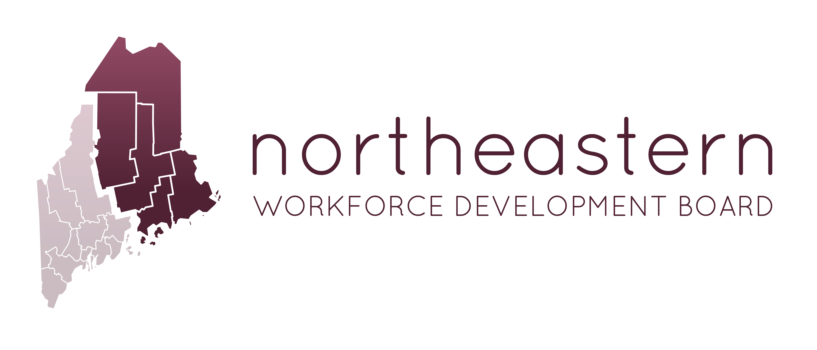

Quarterly NWDB Board Meeting - Zoom
Please Print Clearly
Wednesday, April 25, 2018
4:00pm-5:00pm

Join from PC, Mac, Linux, iOS or Android: https://zoom.us/j/243320662
US: +1 408 638 0968 or +1 646 876 9923 - Meeting ID: 243 320 662

Agenda

- System update – Joanna Russell
- Budget Review – Sara McLaughlin
- Program updates – Service Providers

