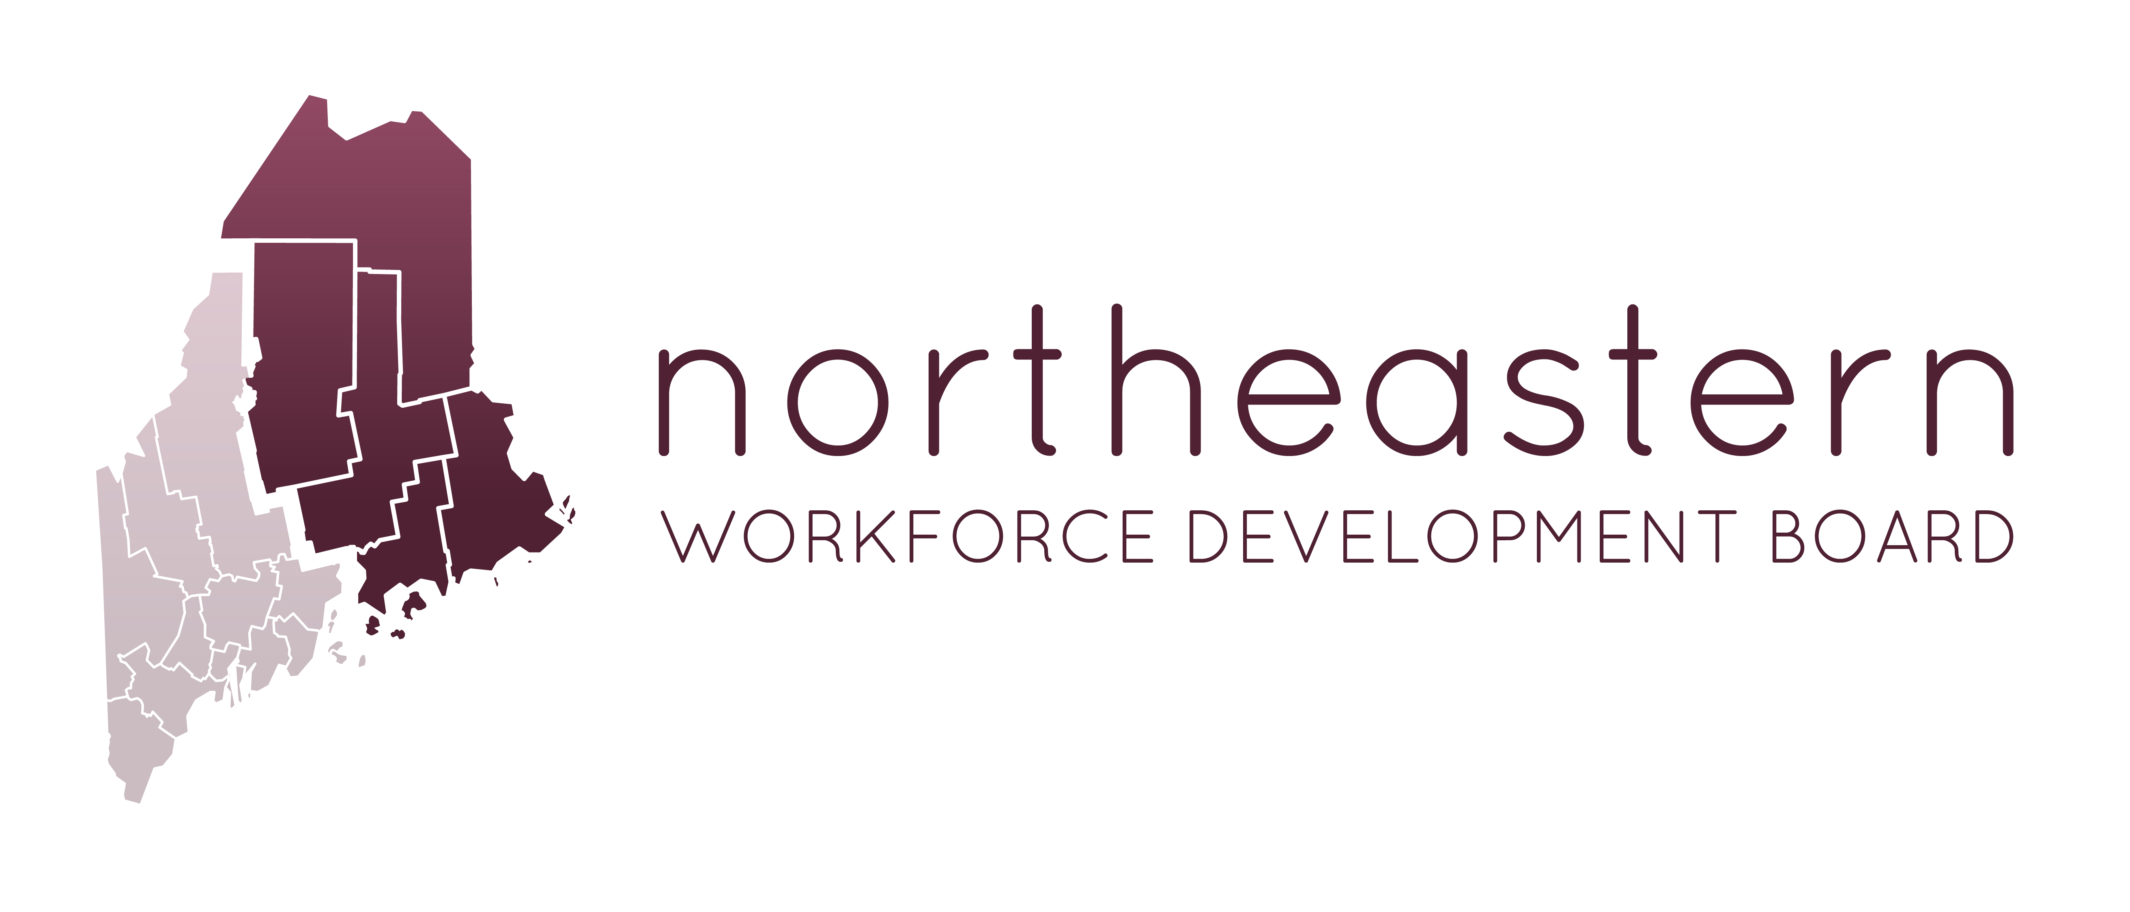

One Stop Partners Meeting

AT: NWDB Office, 26 Franklin Street, Bangor, ME 04401
April 12, 2018 - 1:00PM-3:00PM

Join us in person or from PC, Mac, Linux, iOS or Android:
https://zoom.us/j/532733191
Or Telephone:
1-646-876-9923 Meeting ID: 532 733 191

AGENDA

- Welcome & Housekeeping
- Agenda Review
- Introductions – Name, Organization Name & partner updates
- Board Update – NWDB meeting 4/25/18, 4pm(Zoom)/ Strategic Plan
Work Readiness/ MJL/ Legal Background & Recovery/ Badging-Credentialing
- WIOA Title 1B Program updates
- Work Readiness Programs
- MJL Updates
- Legal Background Checks / Recovery Coaching/ Recovery Centers
- Badging and Credentialing
- Next OSP Meeting- Cycles and Dates

