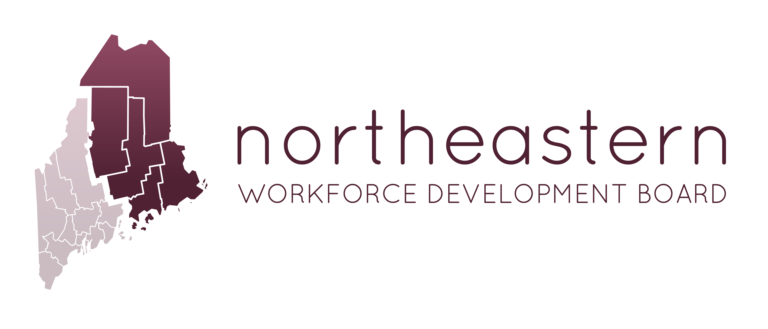

One Stop Partners Meeting

AT: NWDB Office, 26 Franklin Street, Bangor, ME 04401
June 8, 2017 - 1:00PM-3:00PM

Join us in person or from PC, Mac, Linux, iOS or Android: https://zoom.us/j/353268209
Telephone: Dial: +1 646 558 8656 (US Toll), Meeting ID: 353 268 209

AGENDA

- Welcome & Housekeeping
- Agenda Review
- Introductions – Name, Organization Name & partner updates
- Chairperson for OSP?
- Board Update – NWDB meeting June 21,207 Ellsworth Library, Plan, Monitoring, and MOU.
- Maine Job Link
- Maine at Work Initiative
- OSP- MOU & Cost Sharing - Partner Preparation
- Leveraging Resources

